Bangor Fire Department Honor Guard
Merit Awards

The Bangor Fire Department has established a merit award system. This is because; our members donate all of their time, when working as a member of the group. Our members can now receive merit ribbons as a Thank You for their time, effort and commitment.

Funeral Ribbon Award

The Red/White/Blue Ribbon (Funeral) is issued to members who have worked a funeral detail. This award is given because of the time needed for funeral details. Our funeral details could mean that we are doing multiple functions during the ceremonies, as well as standing in formations for extended periods of time.

A large star is added to the ribbon for each 5 funerals that the member attends, up to a total of 3 stars (15+ funerals).

Attendance Award
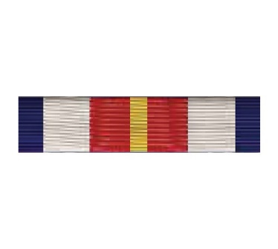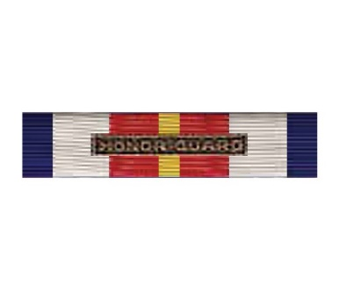

The BLUE/WHITE/RED/YELLOW RIBBON (Attendance) is issued to members who have attended 10 Training/Detail events along with the HONOR GUARD patch rocker. This is approximately 20-30 hours of time. After 20 trainings/details the ribbon is upgraded to one with HONOR GUARD with brass attached.
A small Star is added to the ribbon for each 10 sessions after the brass ribbon is issued, up to a total of 2 stars (40 Training/Details). After a member has attended 50+ details/Training sessions, then the small stars are replaced by 2 large stars.

Joint Service Award

The Blue/White/Green Ribbon (Joint Service) is issued to members who have worked 1 detail or more with the MeANG as part of their unit. This means that we were asked by them to help fill one of their details in some role. This is issued because the MeANG has very set procedures that they need to do in military functions. Members need to practice some of the details more than others. They appreciate our unit assisting them, so we appreciate our members who step up for this additional duty.

PALL BEARER

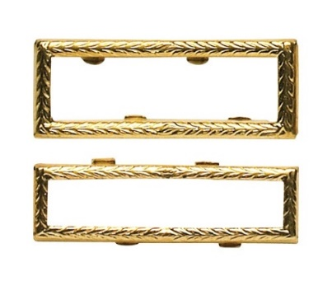

A GOLD CITATION FRAME may be issued to wear around either the Funeral Ribbon Award or the Joint Services Award to indicate participation in a funeral as a pall bearer. This award is given because the time needed to practice proper techniques during a casket ceremony is higher than normal. These members should be recognized for their efforts.

Positioning on the Class A uniform –
The ribbon(s) shall be worn over the badge.
~ If a single ribbon is worn, then it shall be centered, one finger over the badge.
~ If two ribbons are worn, then they shall be centered, one finger over the badge.
The order of the ribbons (L-R) shall be: Funeral – Attendance, Attendance - Joint, Funeral - Joint. The order of importance is: Funeral, Attendance, Joint Service.
~ If three ribbons are worn, then the order will be Funeral - Attendance with the Joint ribbon worn centered over the pair

